The 18th Bitumen, Asphalt & Machinery Conference & Exhibition
60 mm
30 mm
Minimum 90mm and maximum 120 mm

Title: 1 or 2 Lines, Single Space, Times 16pt, Bold
First Author¹, Second Author², … (Times New Roman 12pt, Bold)
1- First Author’s Affiliation and Short Address (Times New Roman 10pt, Bold)
2- Second Author’s Affiliation and Short Address
Note:
• Joint addresses should be mentioned only once, for example:
1,3- first and third author address
2- second author
• A single address doesn’t take any number when all authors have a common address.
Corresponding Author’s E-mail (Times New Roman 10pt)
Abstract (Times New Roman 12pt, Bold)
Each paper must be accompanied by a 150 to 200-word abstract, written as a single paragraph, having a 40^{mm} distance from the left and 40^{mm} from the right sides. It should be a summary (not an introduction) and complete in itself, indicating the subjects, objectives, method of investigation, and distinct achievements. The abstract should be prepared in Times New Roman font size 12pt. Place it between 90^{mm} and 120^{mm} from the top of the page. Remove unnecessary objects from this guide before file submission.
40 mm
40 mm
Keywords: Maximum 5 words separated by comma, Times New Roman 12pt Bold.

Introduction (Times New Roman 11 Bold, 20pt from above, 10pt from bellow)
This direction provides required guidelines to authors to write their English papers in accordance with an identical standard format acceptable to this conference. The fulfillment of these instructions is mandatory for all contributors. Note that the appearance of this guide sheet conforms to the suggested directions and can be used for preparing your own paper after removing the guiding boxes/signs.
30 mm
25 mm
The authors of English papers are requested to use Microsoft Word 2007 or above to create their final docx and pdf files with embedded fonts. Use Times New Roman 10pt and single space for paper body text. The full paper should be formatted in a single column with the margins specified on this template (30^{mm} from the top and left and 25^{mm} from the right and bottom). Each section title or subtitle should be appeared in Times New Roman 11pt in the bold face with 20pt from its preceding section and 10pt from the following text. Always number section titles and subtitles. The first line of each paragraph, except the one appearing immediately after the title of each section, should have an indentation equal to 10^{mm}.

Submission of Papers
All papers will take the evaluation process to the referee committee. For a paper to be considered for evaluation, the authors should submit their full-length paper in docx and pdf formats with embedded fonts. Make sure you revoke the “Do not send fonts to Adobe Acrobat” option while creating the pdf file. Please include all relevant materials (text and accompanying figures) in a single document.
The acceptance of received papers will be communicated with the corresponding author and can be tracked by all authors through the conference website. A paper that receives final or conditional acceptance should be prepared regarding the requested corrections, and the paper should be sent again via the conference website.

Page Limitation
Full papers, including the main body, figures, tables, and references, should be less than 10 pages.

Footnotes
All footnotes, if necessary, should be inserted with Times New Roman 9 pt Font, separated from the main body text by a line.

Equations
All equations (in one or more lines) must be written on the left of the line with Times New Roman font and appropriate size. Number all equations sequentially from 1. Each equation number should be right justified and written in parentheses. Relevant theories and equations should essentially be adequate and not too elaborate. Note the following sample equation:
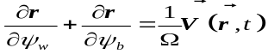 (1)
where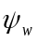 and 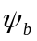 are … and … respectively for a particle with velocity at position and time.

Introducing Variables and Symbols
Since it is not necessary to present terminology at the beginning of the paper, each variable or symbol used in the text must be clearly defined after its first appearance.

Units
The acceptable system of units is standard metric (SI), and all variables and numerical values should be expressed in metric units. Authors should clearly write units of quantities inserted in tables or used as labels of drawing axes.

Figures and Drawings
All figures and drawings must be placed within the text immediately after they are first cited, centered in the text, preceded by one, and followed by two blank lines. Drawings must be clear and sharp. Illustrations’ letters, numbers, and legends should be large enough to be legible. Each figure must have a number and a caption; see Figure 1. Captions should be placed below the figures and written in Times New Roman 9 pt Boldface. All figures should be cited within the text. The placement must be “In Line with Text.”
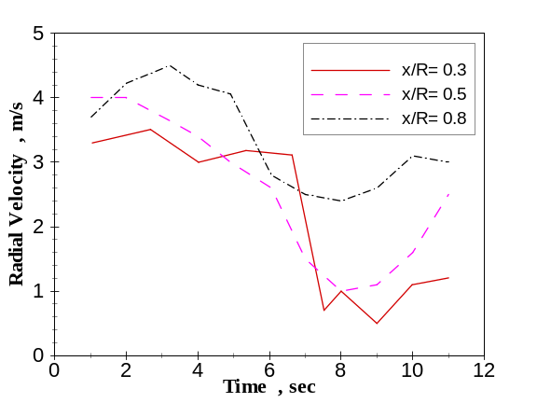
Figure 1- Time variation of radial velocity

Tables
All tables must be placed within the text immediately after they are first cited, centered in the text, preceded by one, and followed by two blank lines. Tables must have a number and a caption; see Table 1. Captions should be placed above the tables and written in Times New Roman 9 pt Boldface. All tables should be cited within the text.
Table 1- Computed parameters at two considered sections for U=20 m/s
 | V_{p} (m/s) | T (K)
Computed results in section #1 | 18 | 311
Computed results in section #2 | 24 | 294

Conclusions
Each paper should conclude with distinct and effective statements or explanations as highlighted conclusions.

Acknowledgment
This section, if necessary, comes before the references. Acknowledge all funding sources.

References
As the final part of each paper, references should be written by Times New Roman 10 pt. They are to be numbered in the order they appear in the main text and referenced just by numbers within brackets, e.g. [3]. Only references, which are cited in the paper, should be included. For each reference, adequate specifications should be mentioned in a standard format, such as the following examples. If you indicate a document published in Persian, please add the expression ‘(in Persian)’ at the end of it.

- Areias, P. M. A. and Belytschko, T. (2014), “Analysis of Three-Dimensional Crack Initiation and Propagation Using the Extended Finite Element Method”, International Journal for Numerical Methods in Engineering, 63 (55), pp. 760–788.
- Atluri, S.N. and Shen, S. (2013), “The Meshless Local Petrov–Galerkin (MLPG) Method”, Tech Science Press, USA.
- Udwadia, F. E. and Trifunac, M. D. (2010), “Ambient Vibration Test of Full Scale Structures”, Proc. of the 5th World Conf. On Earthquake Engineering, Rome, pp. 135-142.
- Aghayani-pour, K. and Hakemifar, J. (2008), “Theoretical and Experimental Study of the Strength of Piezoelectric Structures Under Pressure Forces”, Proc. of the 1stConference on Dynamics of Advanced Structures, Mechanics Research Center, Isfahan, pp. 23-25, (in Persian).
- Trifunac, M. D. (2008), “Wind and Microtremor Induced Vibration of a 22 Story Steel Frame Building”, Earthquake Engineering Research Lab., Report EERL 70-01, California Institute of Technology, Pasadena California.
- Sethian, J.A. (2007), “Moving interfaces and boundaries: level set methods and fast marching methods”, http://math.berkeley.edu/~sethian/Explanations/level_set_explain.html.

Footnote

